Government of India
***

Shri Rameswar Teli, Hon'ble Minister of State for Petroleum & Natural Gas and Labour & Employment, visited our Haldia LPG Import Terminal.
Haldia, March 4, 2023

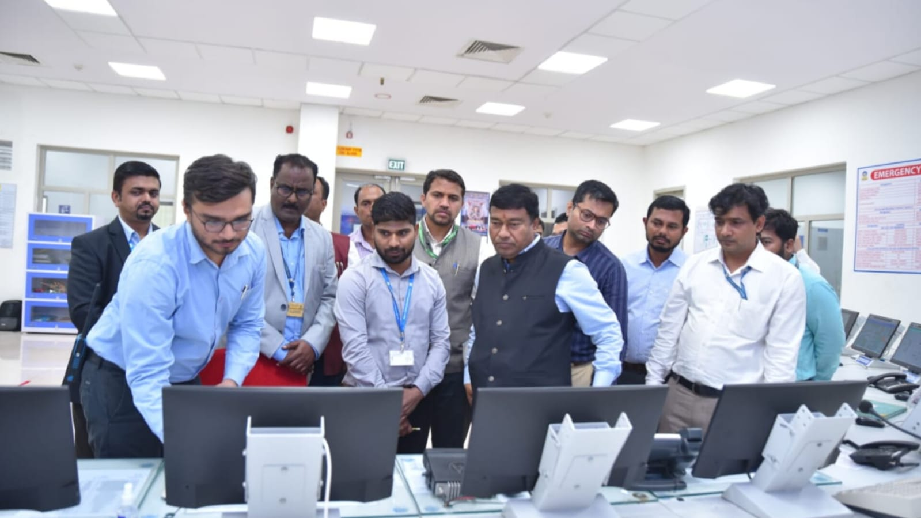
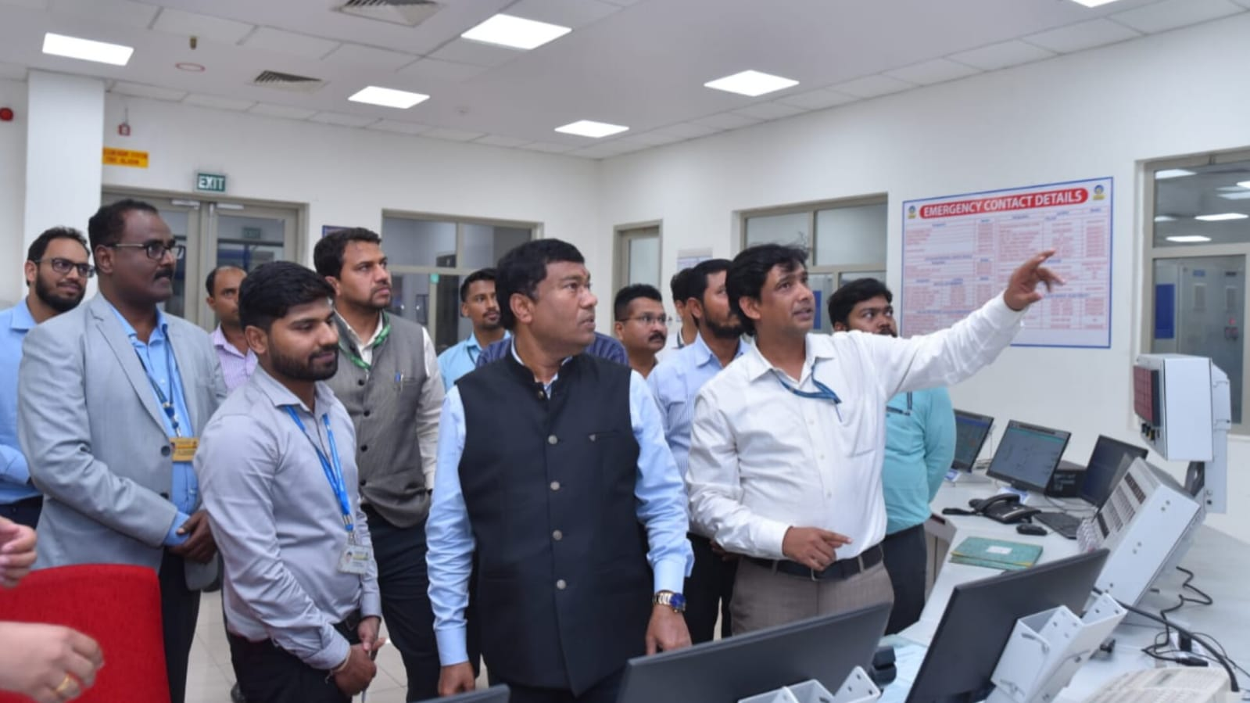
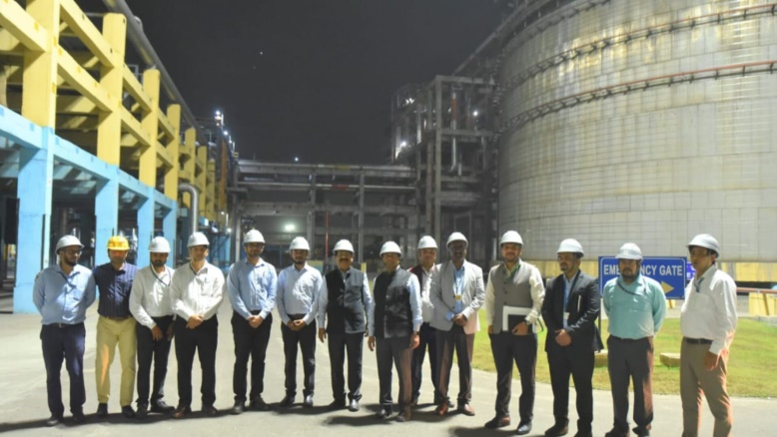
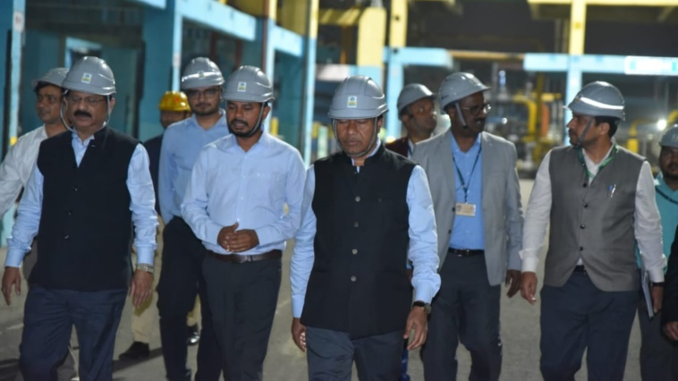
Shri Rameswar Teli, Hon'ble Minister of State for Petroleum & Natural Gas and Labour & Employment, visited our Haldia LPG Import Terminal.
He interacted with all the team members and showed a keen interest in the facilities and operation of the terminal.
Built with an investment of around Rs 1,100 crore and having a capacity of 1 million metric tonne per annum, Haldia Import Terminal caters to the growing requirement of LPG in West Bengal and other eastern and north-eastern states of India, while playing a big role in making India energy secure and developing gas based energy
#Haldia #LPG #WestBengal #NorthEastIndia

